A RFID & BLUETOOTH BASED TOURIST SERVICE PROTOTYPE

AIM:
The main aim of the project is to design a system which uses RFID technology in the museum which provides voice and image information to the visitors.
PURPOSE:
The purpose of the project is to develop a system, which uses android and RFID technology to give the information about a particular person/thing with an image and voice in an easy way.

VISITORS SECTION:

MICRO CONTROLLER
AT89S52

POWER SUPPLY
LCD DISPLAY
(16 X 2 LINES)
M
A
X
2
3
2
BLUETOOTH MODULE
RFID READER

MOBILE UNIT:
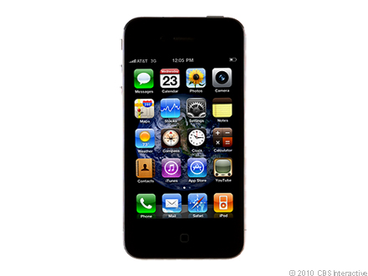
Power Supply:
STEP DOWN
TRANSFORMER
BRIDGE
RECTIFIER
FILTER
CIRCUIT
REGULATOR SECTION

DESCRIPTION:
The project RFID enhances visitor’s museum with voice and image transmission is designed to get the voice and image information of a particular thing/person using RFID technology and android applications.
Here we use this project in museums to get the information in an easy way. In this section we have a RFID reader which is used to read the different tags available in the museum. When a tag is placed in the vicinity of reader it will read the information contained in tag. This information is given to Bluetooth module by microcontroller and this is transferred to Bluetooth inbuilt in the android mobile. The corresponding information or application related to the tag is opened in the android mobile. The image and the text related to that tag is displayed in the mobile and also voice announcement of the same text will be announced from the android mobile. Hence by using this project we can easily get the data or information that we want.
HARDWARE COMPONENTS:
- Microcontroller (AT89S52)
- LCD Display (16x2 lines)
- Max 232
- RFID Reader & tags
- Bluetooth module
- Latch IC.

SOFTWARE:
- Kiel U vision
- Express PCB
- ISP
- Andoid.sdk

RESULT:
By using this project we have implemented a project which gives image/ voice information about person/things using android.

